**Hospital Management System**

Frontend : Angular

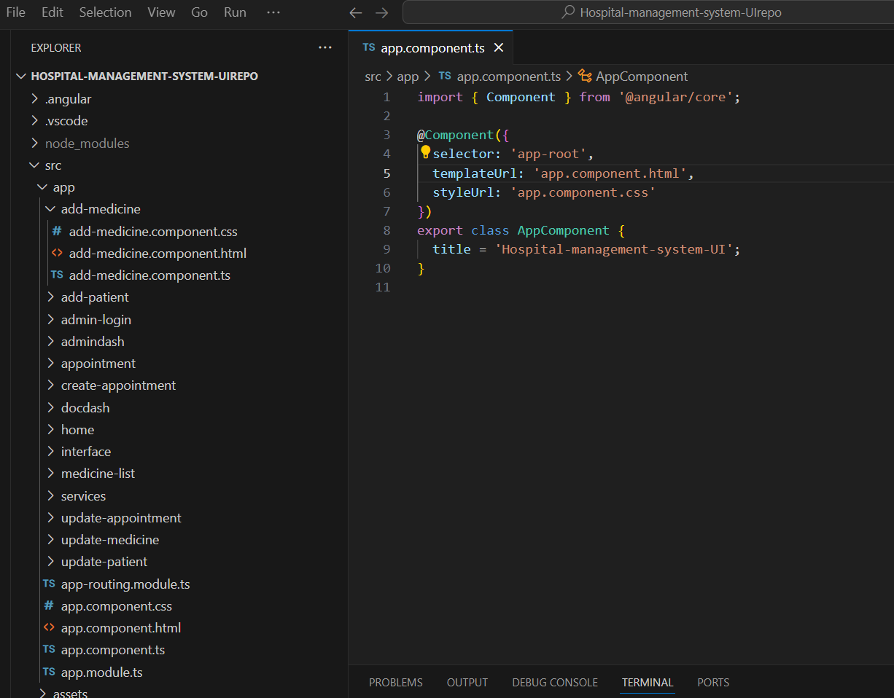

Backend : Springboot

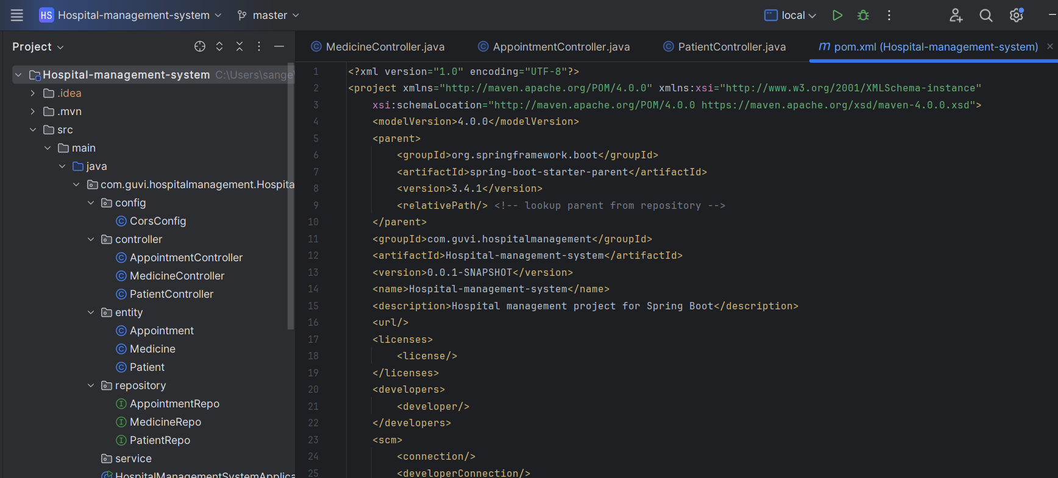

Database : Mysql

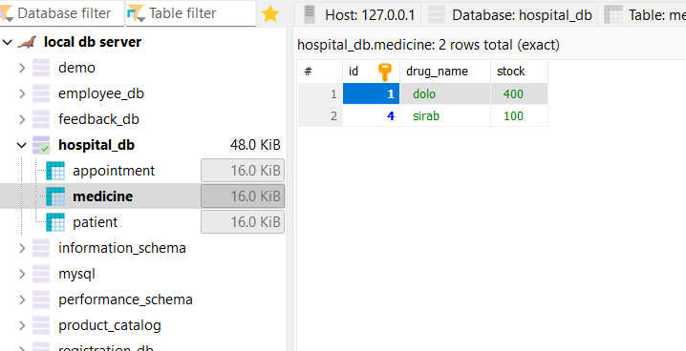

Entity data

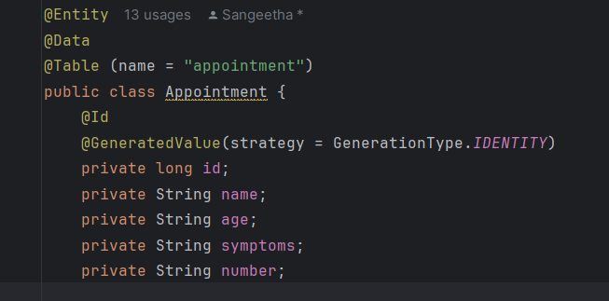

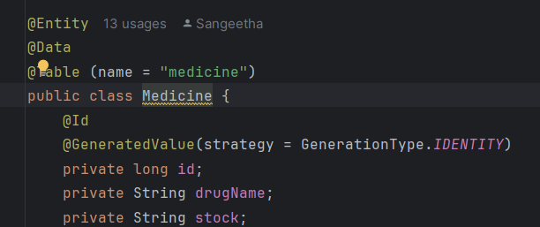

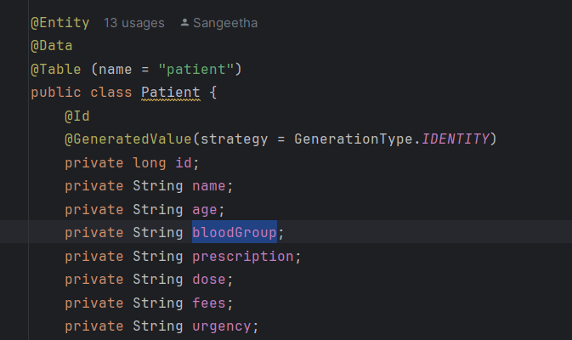

API Endpoints:

patient

http://localhost:8080/hms/patient

http://localhost:8080/hms/patient/{id}

http://localhost:8080/hms/patient/addPatient

http://localhost:8080/hms/patient/deletePatient/{id}

http://localhost:8080/hms/patient/updatePatient/{id}

{

"name":"Sangeetha",

"age":"24",

"bloodGroup":"A+",

"prescription":"dolo 1",

"dose":"1",

"fees":"100",

"urgency":"assnasajddnfk"

}

Appoinment

http://localhost:8080/hms/appointment

http://localhost:8080/hms/appointment/{id}

http://localhost:8080/hms/appointment/addAppointment

http://localhost:8080/hms/appointment/deleteAppointment/{id}

http://localhost:8080/hms/appointment/updateAppointment/{id}

{

"name":"Sangeetha",

"age":"24",

"symptoms":"fever",

"number":"63"

}

Medicine

http://localhost:8080/hms/medicine

http://localhost:8080/hms/medicine/{id}

http://localhost:8080/hms/medicine/addMedicine

http://localhost:8080/hms/medicine/deleteMedicine/{id}

http://localhost:8080/hms/medicine/updateMedicine/{id}

{

"drugName":"dolo",

"stock":"50"

}

